# Deep Learning

Lab – 4

Name: Yadukrishnan

Reg. No: 21BAI1210

Link to all the codes given below: [Github](https://github.com/yadu-tv/deep-learning-lab/tree/main/lab_4)

1. Sample notebook

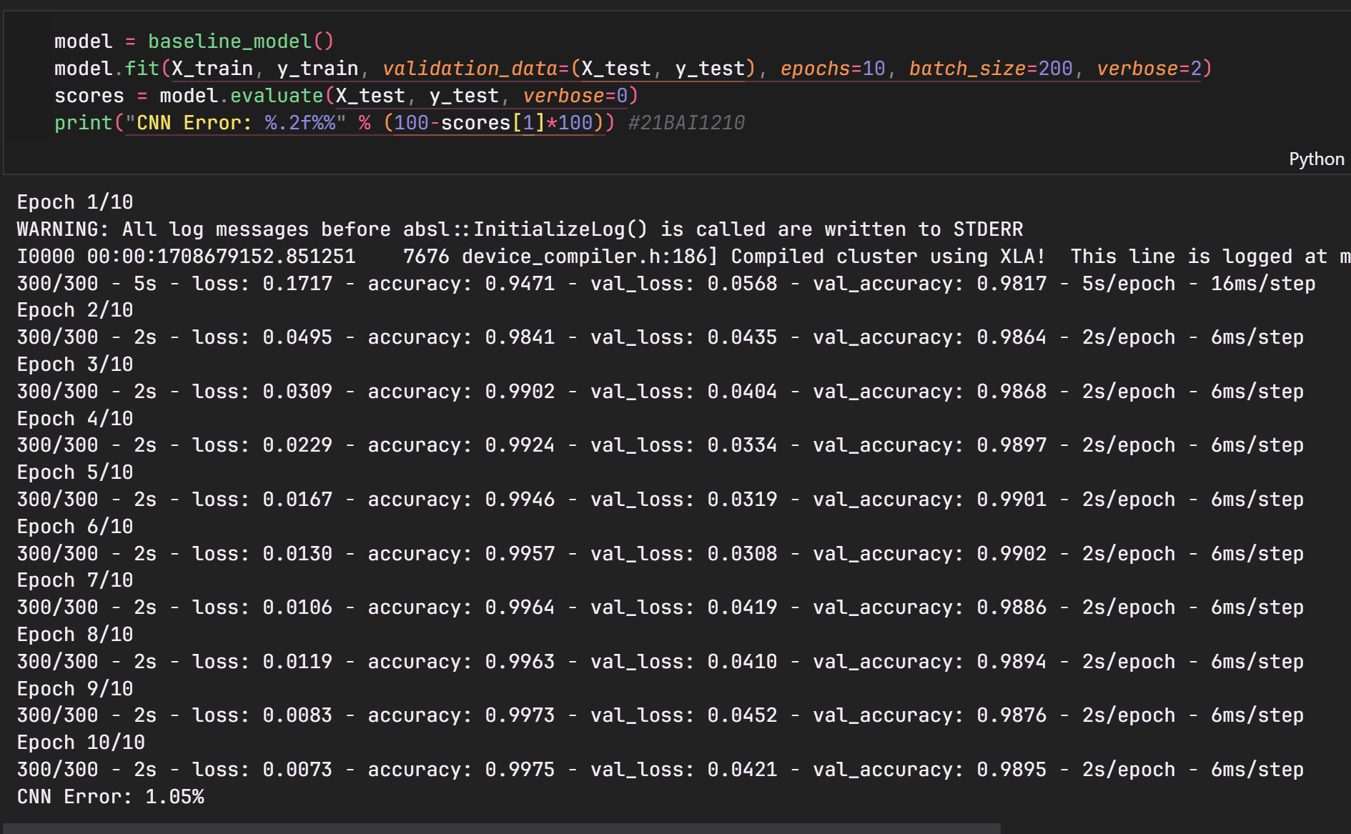

1. Comparison of sample code
   1. Change in stride and padding

* 1. Removing maxpooling

* 1. Change activation function

* 1. Adding multiple dense layers

* 1. Change optimizer to RMSPROP

1. Visualizing features

1. CIFAR10 dataset

1. Full connected NN

